Time Management Matrix

Becoming aware of things to do
Stephen Covey has categorized things to do based on an urgeny-importancy matrix. According to this, we can divide our tasks in 4 groups:
- Urgent and important tasks
- Urgent and less important tasks
- Not-urgent and important tasks
- Not urgent and not important tasks
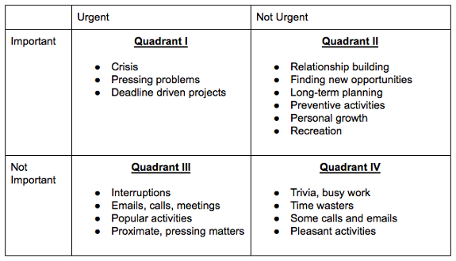

Steps to follow when planning our time (Covey, 2004):
- Define all the tasks at hand (You can make a list of all the tasks without an order.)
- Define those tasks with priority (After making the list, you can change the order considering the urgency and importancy of tasks.)
- Estimate the time each task requires (Please be realistic when doing so.)
- Estimate the total time required for these tasks and divide it amongst tasks (At this point, some tasks might fall down a place due to them being not important relative to others. You can make another plan to get to these later on.)
- Revise your plan accordingly (If some tasks require more time than you estimated, you can reorganize your plan and stick to being realistic about your plan. Usually, even if we exceed the time spared for a task we believe we still can meet the deadlines. However, spending more time on a task can decrease our motivation. Revising the plan throughout the process can help us complete it without falling into procrastination.

