Özlem Ayduk
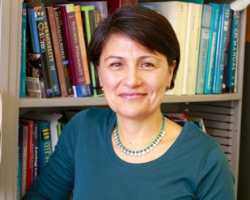

University of California
Professor of Psychology
Director, Relationships and Social Cognition Lab.
Fellow, Society of Personality & Social Psychology

Professor Özlem Ayduk received her B.A. in Psychology and Political Science from Boğaziçi University (1992) and her Ph.D. from Columbia University (1999) where she worked with Prof. Walter Mischel. She joined the Psychology Department at the University of California, Berkeley, in 2002 as an Assistant Professor and became full Professor in 2015.

Professor Ayduk’s research interests focus on the risk and protective factors in interpersonal relationships, self-distancing and its role in emotion regulation and on the development of self-control and emotion competencies in young children. She is currently the Thomas and Ruth Ann Hornaday Chair in Psychology, and a fellow of the American Psychological Society, the Society of Personality & Social Psychology, and the Society of Experimental Social Psychology.

